Ralphie May Documentary
COME WHAT MAY
Continues Nationwide Theatrical Roadshow
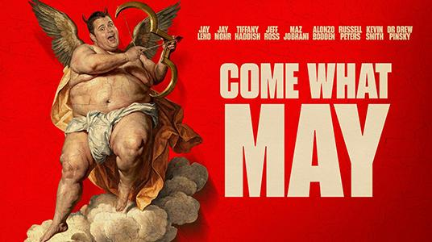
Comedian and filmmaker Lahna Turner brings the intimate, unflinching portrait of her late husband to select cities for one-night-only screenings, Q&As, and special appearances

WHAT:
Comedian and filmmaker Lahna Turner brings COME WHAT MAY to Tempe on May 20 for a one-night-only screening and Q&A, sharing an intimate, unflinching documentary about the life, comedy, struggles, and complicated legacy of her late husband, beloved comedian Ralphie May.

Directed by David Gantz and Lahna Turner, COME WHAT MAY honors Ralphie’s legacy with the same unfiltered truth, heart, and humor that made him a cultural icon, while exploring a story shaped by love, loss, addiction, resilience, and the complicated legacy he left behind. Told through candid interviews, archival footage, and deeply personal reflection, the film features appearances from Jay Leno, Bob Saget, Jay Mohr, Tiffany Haddish, Jeff Ross, Maz Jobrani, Alonzo Bodden, Russell Peters, Kevin Smith, and Dr. Drew Pinsky.

Following early roadshow stops in Los Angeles, Burbank, Las Vegas, and Houston, COME WHAT MAY will continue bringing the film directly to audiences through select one-night-only theatrical screenings, with Q&As, filmmaker appearances, and special guests planned in select cities.

MATERIALS:
- Trailer: Download | YouTube | 45s Teaser
- Poster: Download | Social Version (4x5) | Banner (16x9)
- Social Graphic: Download
- Website: comewhatmayfilm.com

UPCOMING ROADSHOW SCREENINGS

Tempe, AZ
Wednesday, May 20, 2026
Harkins Theatre, Tempe Marketplace
Q&A to follow screening

Dallas, TX
Sunday, June 14, 2026
Texas Theatre

Nashville, TN
Thursday, June 18, 2026
Belcourt Theatre

Austin, TX
Wednesday, June 24, 2026
Galaxy Austin

Waukesha, WI
Wednesday, July 8, 2026
Marcus Majestic-Brookfield
Lahna Turner scheduled to appear in person

PRESS OPPORTUNITIES:
Interview opportunities with Lahna Turner are available ahead of select screening. Media are also invited to cover upcoming screenings and Q&As. Screeners and additional information are available upon request.

MEDIA CONTACT:
Jeremy Bonds
jbonds@motivpr.com

